AWS IAM User Group Creation & Access Report
Practical implementation report based on AWS Management Console screenshots

1. Objective
The objective of this practical is to create AWS Identity and Access Management (IAM) users, organize them into a common IAM user group, and assign permissions through an IAM policy. The screenshots document the complete workflow from user creation through group creation and final access verification.

2. AWS IAM Overview
AWS IAM is used to control authentication and authorization for AWS resources. An IAM user represents a person or application identity, while an IAM group is a collection of users to which permissions can be assigned collectively. Attaching permissions to a group makes access management easier when multiple users need the same level of access.

3. User Creation
The first part of the workflow creates an IAM user named “Abhishek”. Console access is enabled and an autogenerated password is selected. The AWS console also shows the option to require a password change at next sign-in.
- User name: Abhishek
- Console access: Enabled
- Password type: Autogenerated
- Password reset at next sign-in: Not required in the shown configuration
Summary: The user is created with AWS Management Console access. The password is displayed only during the retrieval step, so it should be stored securely.

4. Initial Permission Assignment
During the permission step, the workflow uses the “Attach policies directly” option. The policy search is filtered for S3-related policies, and “AmazonS3FullAccess” is selected.
- Permission method shown: Attach policies directly
- Selected policy: AmazonS3FullAccess
- Policy type: AWS managed
- Effect: Provides full access to Amazon S3 resources covered by the policy
Summary: This gives the created user broad S3 permissions. For production environments, permissions should normally be limited to only the actions and resources required by the user’s job.

5. Review and Create User
The review screen confirms the user name, autogenerated console password, password-reset setting, and attached AmazonS3FullAccess policy. Selecting “Create user” completes the IAM user creation process.

6. Retrieve Console Sign-in Details
After creation, AWS displays the console sign-in URL, IAM user name, and autogenerated console password. The page states that this is the only time the password can be viewed or downloaded.
- Console sign-in URL is generated for the AWS account.
- IAM username: Abhishek.
- Autogenerated password is available on the retrieval screen.
- A CSV download option is provided for the sign-in details.
Security note: Passwords and sign-in credentials should not be shared in screenshots, reports, chat messages, or public repositories.

7. IAM User Sign-in and AWS Console Access
The sign-in screen demonstrates IAM-user authentication using the AWS account ID, IAM username, and password. After successful authentication, the AWS Console home page is displayed.
- IAM user authentication is separate from the root-user login.
- The signed-in user can access only the AWS services permitted by the attached policies.
- The console shows the active AWS region as Europe (Stockholm) in the demonstrated session.

8. S3 Access Verification
The AWS Console shows Amazon S3 in the recently visited services and opens the S3 homepage successfully. This is consistent with the assigned S3 access policy and demonstrates that the IAM user can reach the S3 service.
The S3 homepage also provides the option to create a bucket and describes S3 as an object storage service. Actual bucket-level operations remain subject to the applicable IAM and resource policies.

9. EC2 Access Observation
The EC2 dashboard is also shown. Several EC2 dashboard resources display “Access denied”, indicating that the user does not have the required permissions for those EC2-related actions. The dashboard therefore provides a useful demonstration that IAM permissions are service-specific rather than automatically granting access to every AWS service.
- EC2 dashboard is reachable.
- Multiple EC2 resource panels report Access denied.
- This indicates missing permissions for those EC2 actions.
- S3 access and EC2 access are controlled independently by IAM policies.

10. IAM User List
The IAM users page shows four users: Abhishek, Abhishek2, Abhishek3, and Abhishek4. The screenshot indicates that the users exist in the AWS account and that the original Abhishek user has recorded console activity.
IAM User | Group Membership Shown | Observed Status
Abhishek | 1 | Console activity shown
Abhishek2 | 0 before group creation | User exists
Abhishek3 | 0 before group creation | User exists
Abhishek4 | 0 before group creation | User exists

11. IAM User Group Creation
A new IAM user group named “abhishek_group” is created. During creation, all four IAM users are selected to be members of the group. The group creation screen also provides an optional section for attaching permission policies.
- Group name: abhishek_group
- Users added: Abhishek, Abhishek2, Abhishek3, Abhishek4
- Number of users in group: 4
- Group-level permissions are configured through attached policies.

12. Group Permission Assignment
The group creation workflow shows the IAM policy search and the selection of “IAMFullAccess”. The selected policy is an AWS-managed policy and is attached at the group level. Consequently, the users who are members of the group inherit the permissions defined by that group policy.
- Selected group policy: IAMFullAccess
- Policy type: AWS managed
- Policy attached to: abhishek_group
- Users receiving group permissions: 4
Important: IAMFullAccess is a broad administrative permission set for IAM. It should be used only when the users actually require IAM administration. A least-privilege policy is preferable for normal application or service access.

13. Group Creation Confirmation
AWS confirms that “abhishek_group” was created successfully. The group list shows one group, four users, and the Permissions column marked as defined.

14. Final Group Details and Access
The final group details page confirms the group name, creation time, ARN, four users, and the Permissions tab. The Users tab lists Abhishek, Abhishek2, Abhishek3, and Abhishek4, each showing membership in one group.
- Group: abhishek_group
- Members: 4 IAM users
- Group membership: 1 group per listed user
- Permissions: Defined at the group level
- Group ARN is displayed on the summary page

15. Access Model Summary
Component | Configuration shown | Access implication
IAM User | Abhishek | Can authenticate to AWS Console
Direct policy | AmazonS3FullAccess | Broad S3 access
IAM Group | abhishek_group | Centralizes permissions for members
Group members | 4 users | All selected users inherit group permissions
Group policy | IAMFullAccess | Broad IAM administration permissions
EC2 dashboard | Access denied on several panels | No corresponding EC2 permissions shown

16. Conclusion
The practical successfully demonstrates AWS IAM user creation, policy attachment, console sign-in, user-group creation, group membership, and group-based access management. The final configuration contains four IAM users in the abhishek_group group, with IAMFullAccess attached at the group level. The screenshots also demonstrate that access to AWS services such as S3 and EC2 depends on the permissions granted to the identity.

17. Security and Best-Practice Notes
- Prefer IAM groups for common permissions instead of attaching identical policies separately to many users.
- Use least-privilege policies and grant only the actions required for a task.
- Avoid using broad policies such as IAMFullAccess unless administrative IAM access is genuinely required.
- Enable MFA for IAM users where appropriate.
- Do not include passwords, access keys, or other credentials in reports or screenshots.
- For programmatic access, prefer temporary credentials/roles where applicable and rotate long-term credentials when they must be used.

18. Screenshot Evidence
The following screenshots are included as evidence of the workflow. Each image is labeled with the activity it represents.
Screenshot 1 – Specify user details
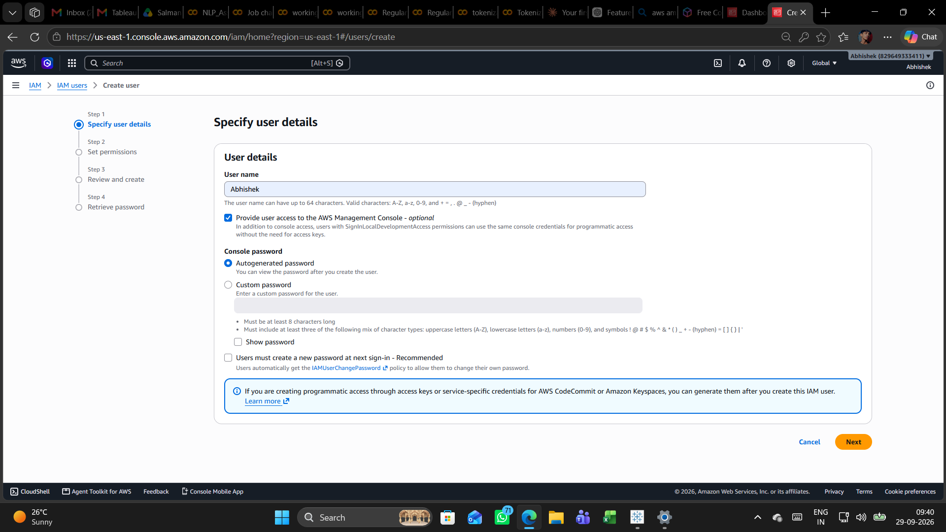
Screenshot 2 – Set permissions / S3 policy search
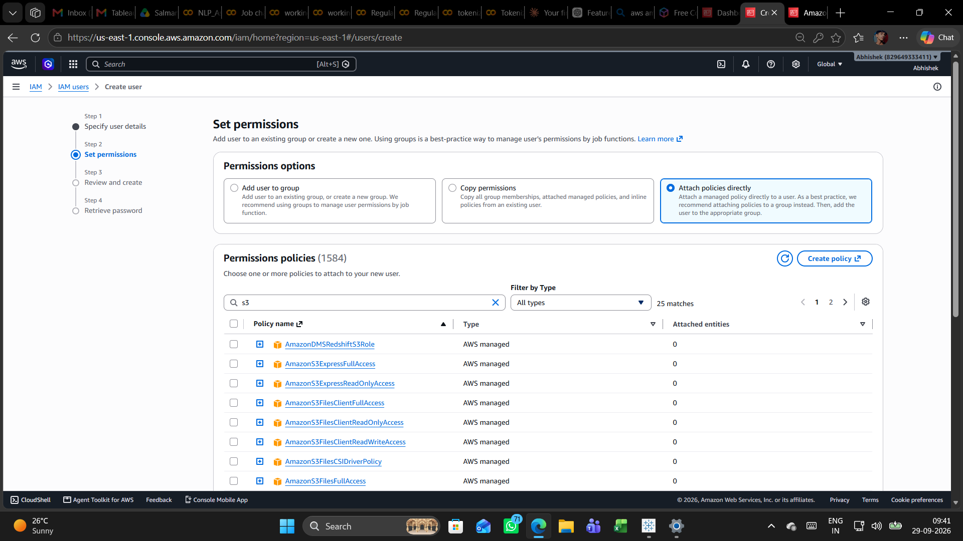
Screenshot 3 – AmazonS3FullAccess selected
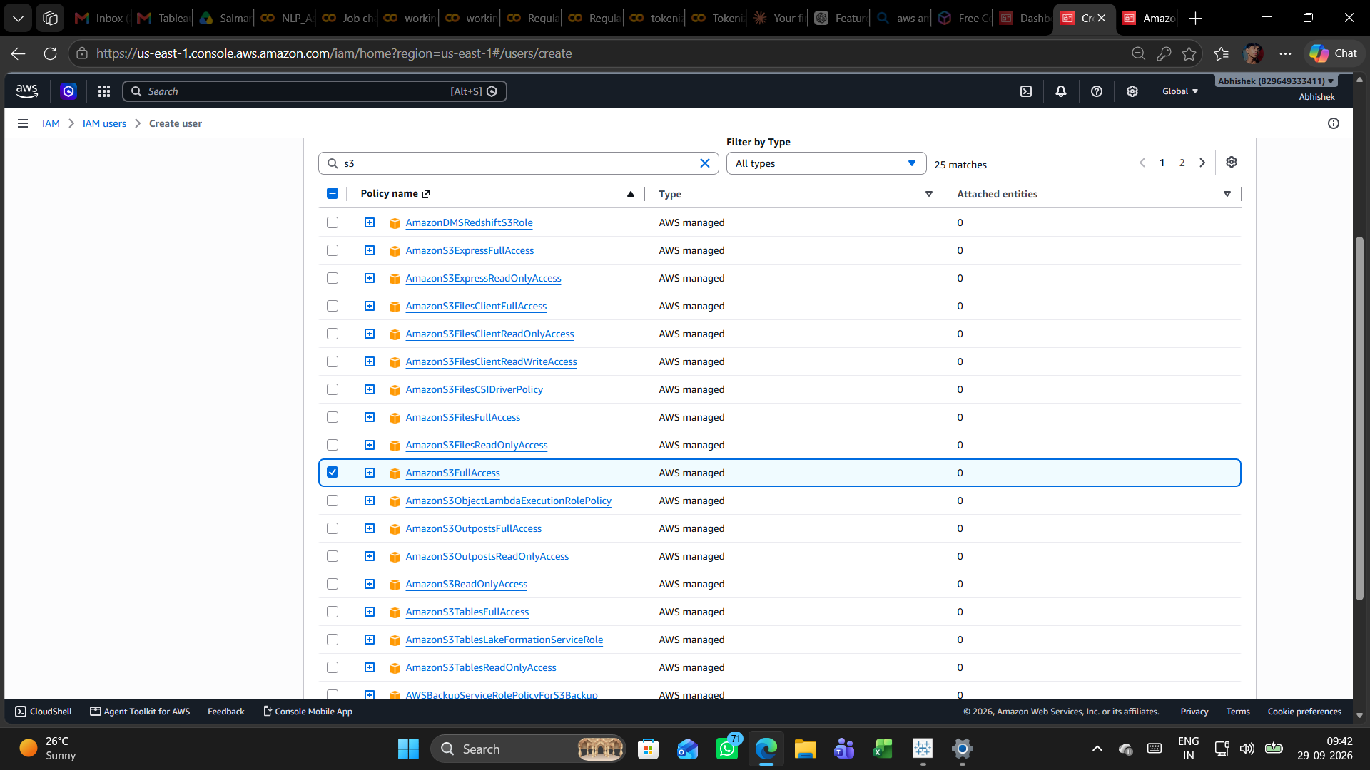
Screenshot 4 – Review and create user
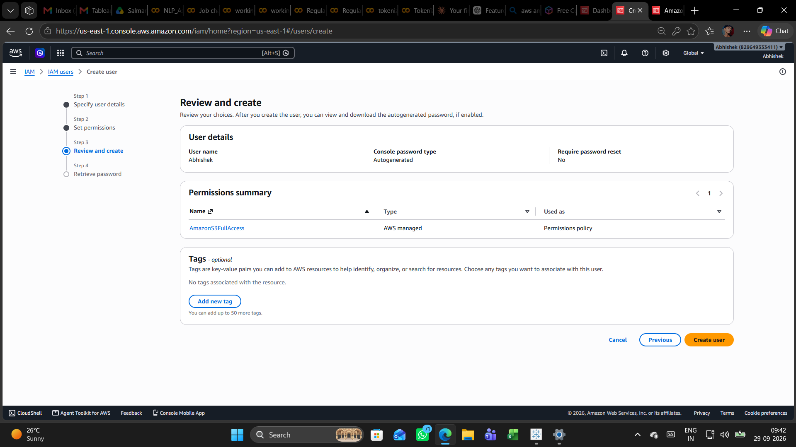
Screenshot 5 – Retrieve password and sign-in details
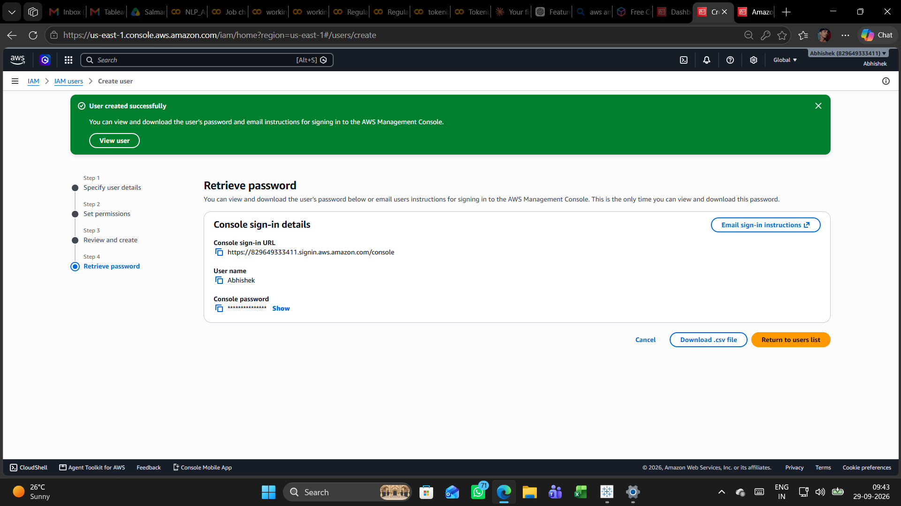
Screenshot 6 – IAM user sign-in
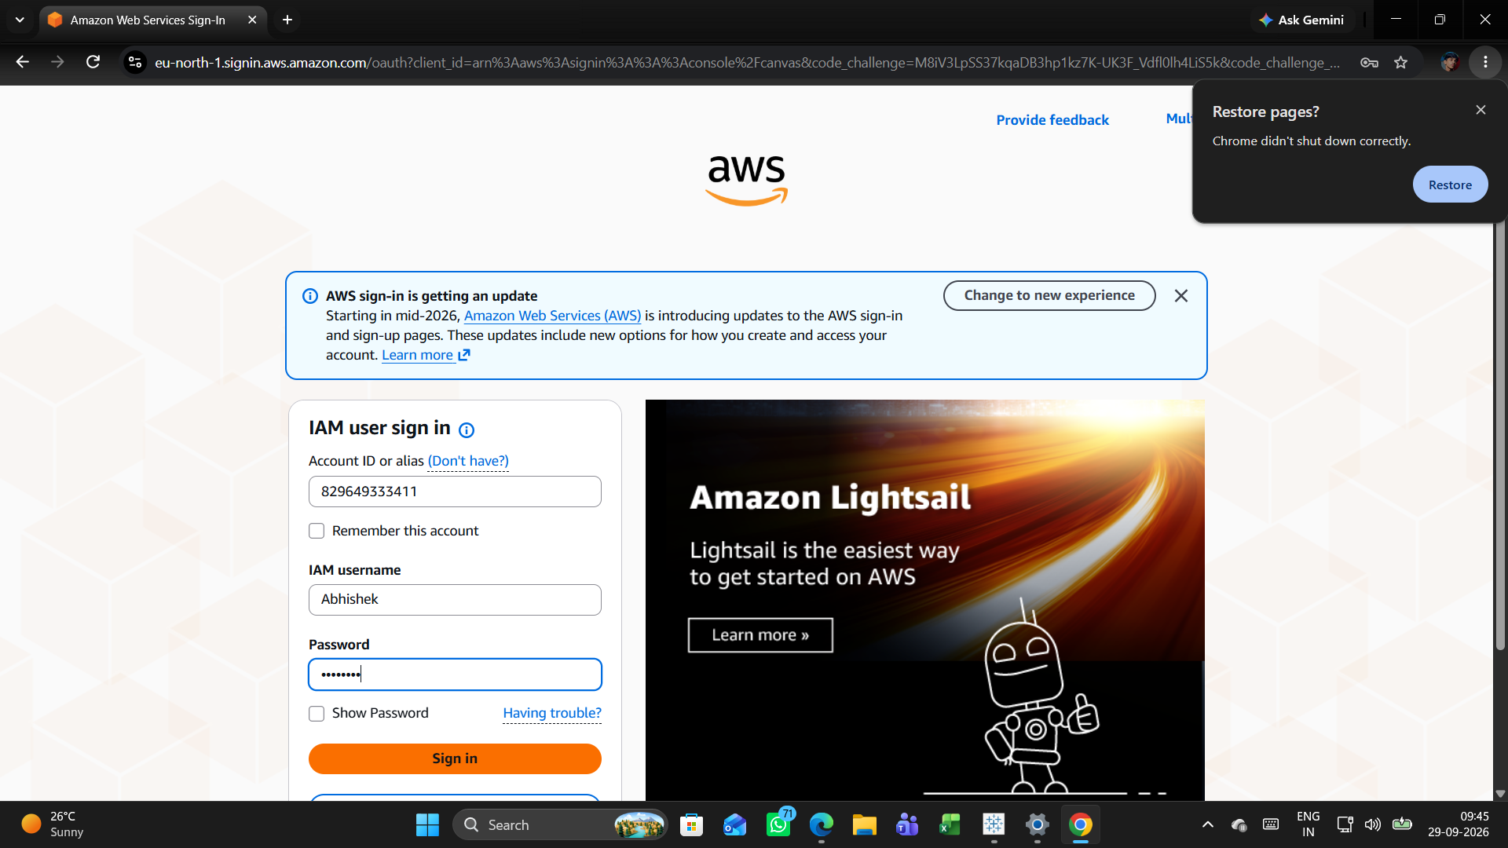
Screenshot 7 – AWS Console home
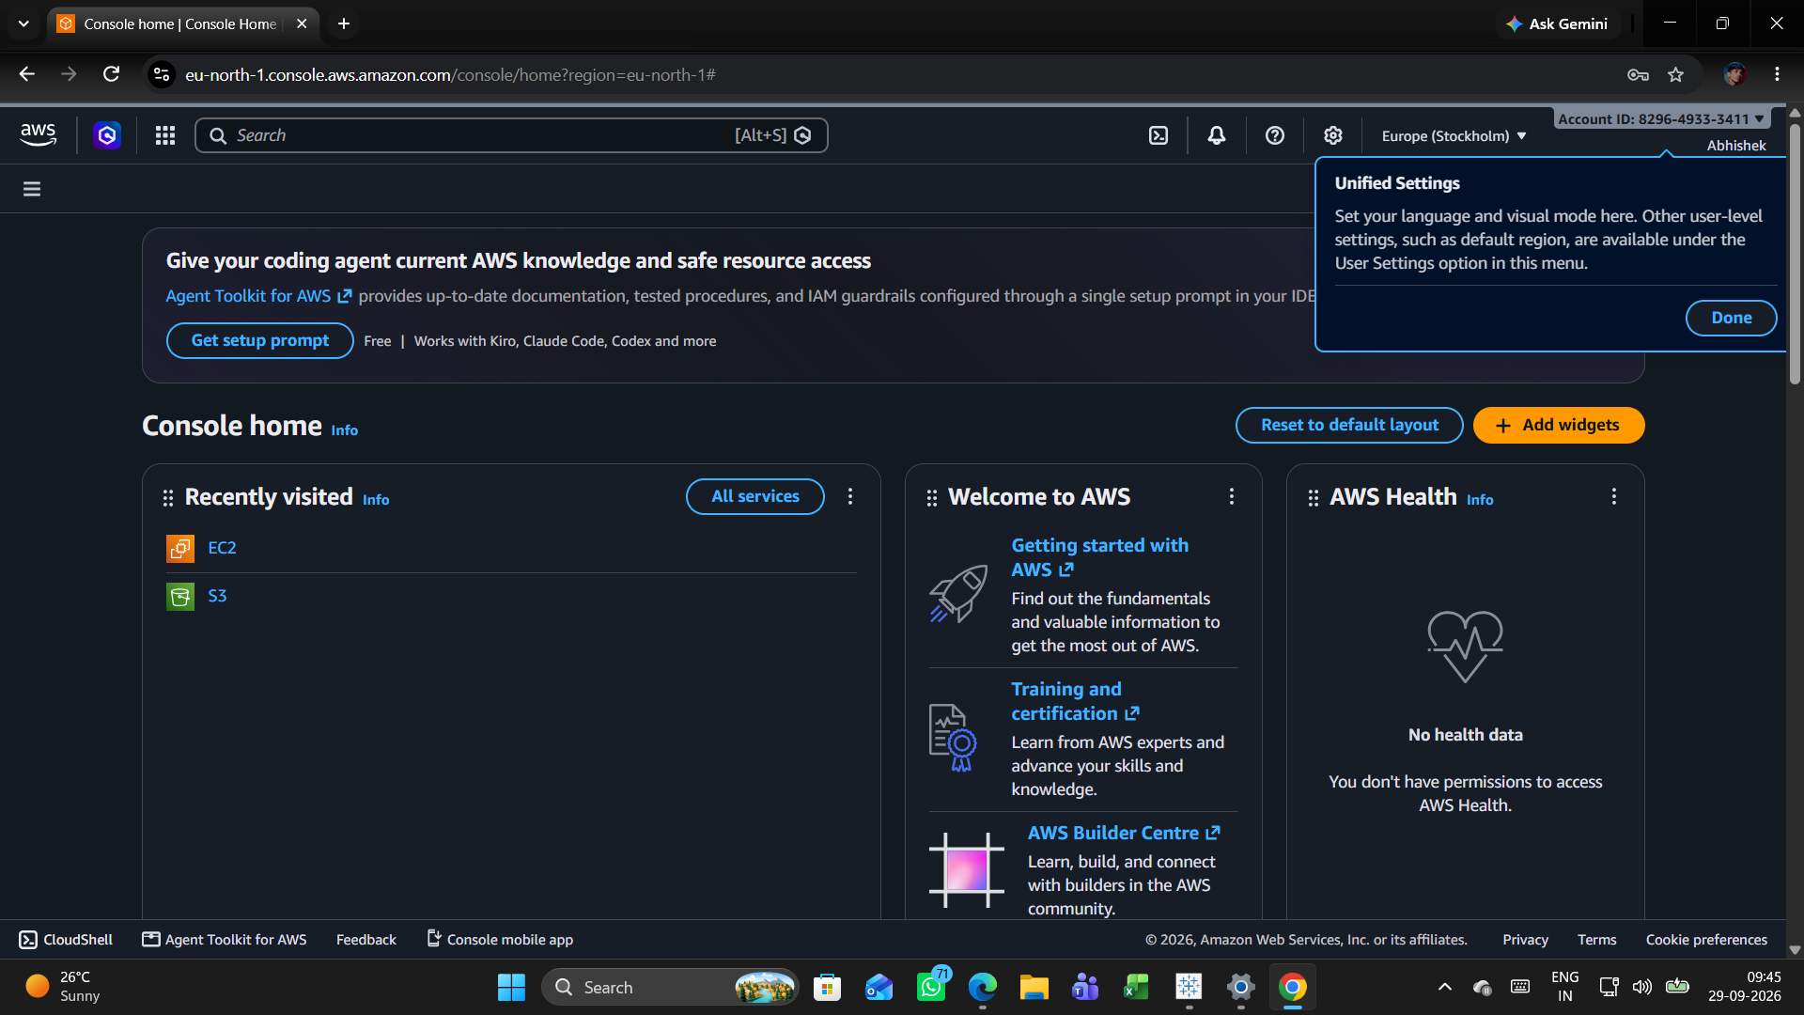
Screenshot 8 – Amazon S3 console
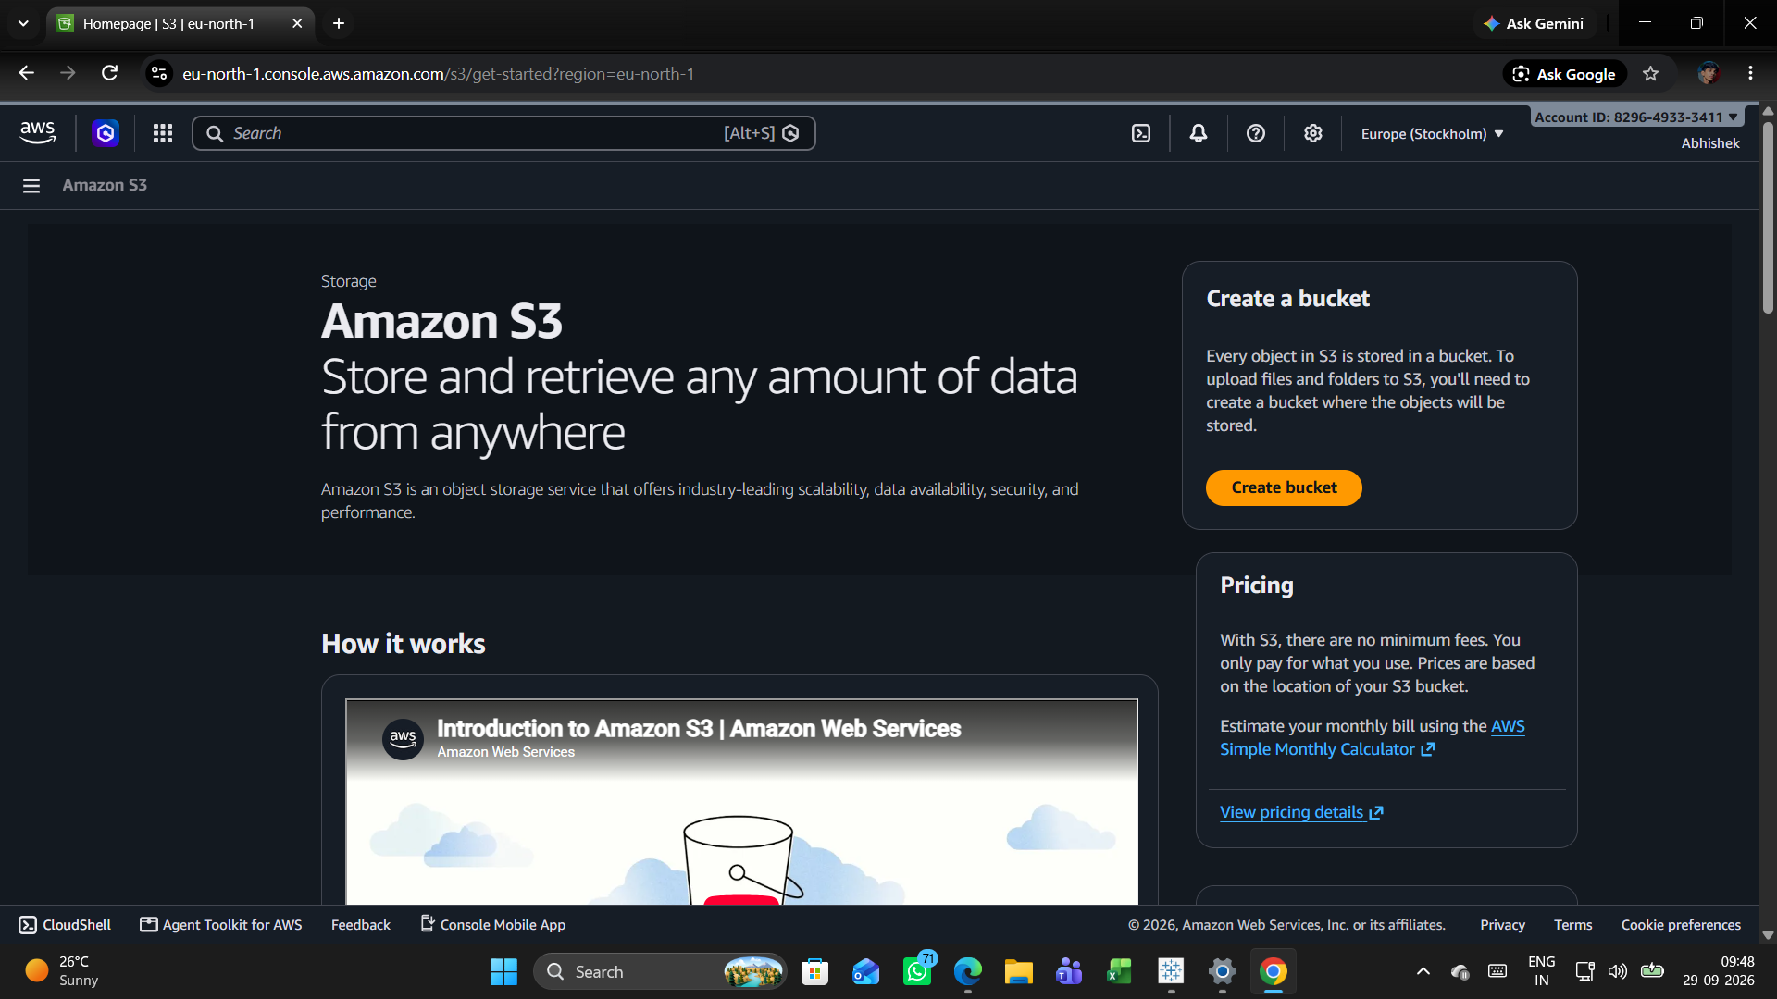
Screenshot 9 – EC2 dashboard and access-denied observations
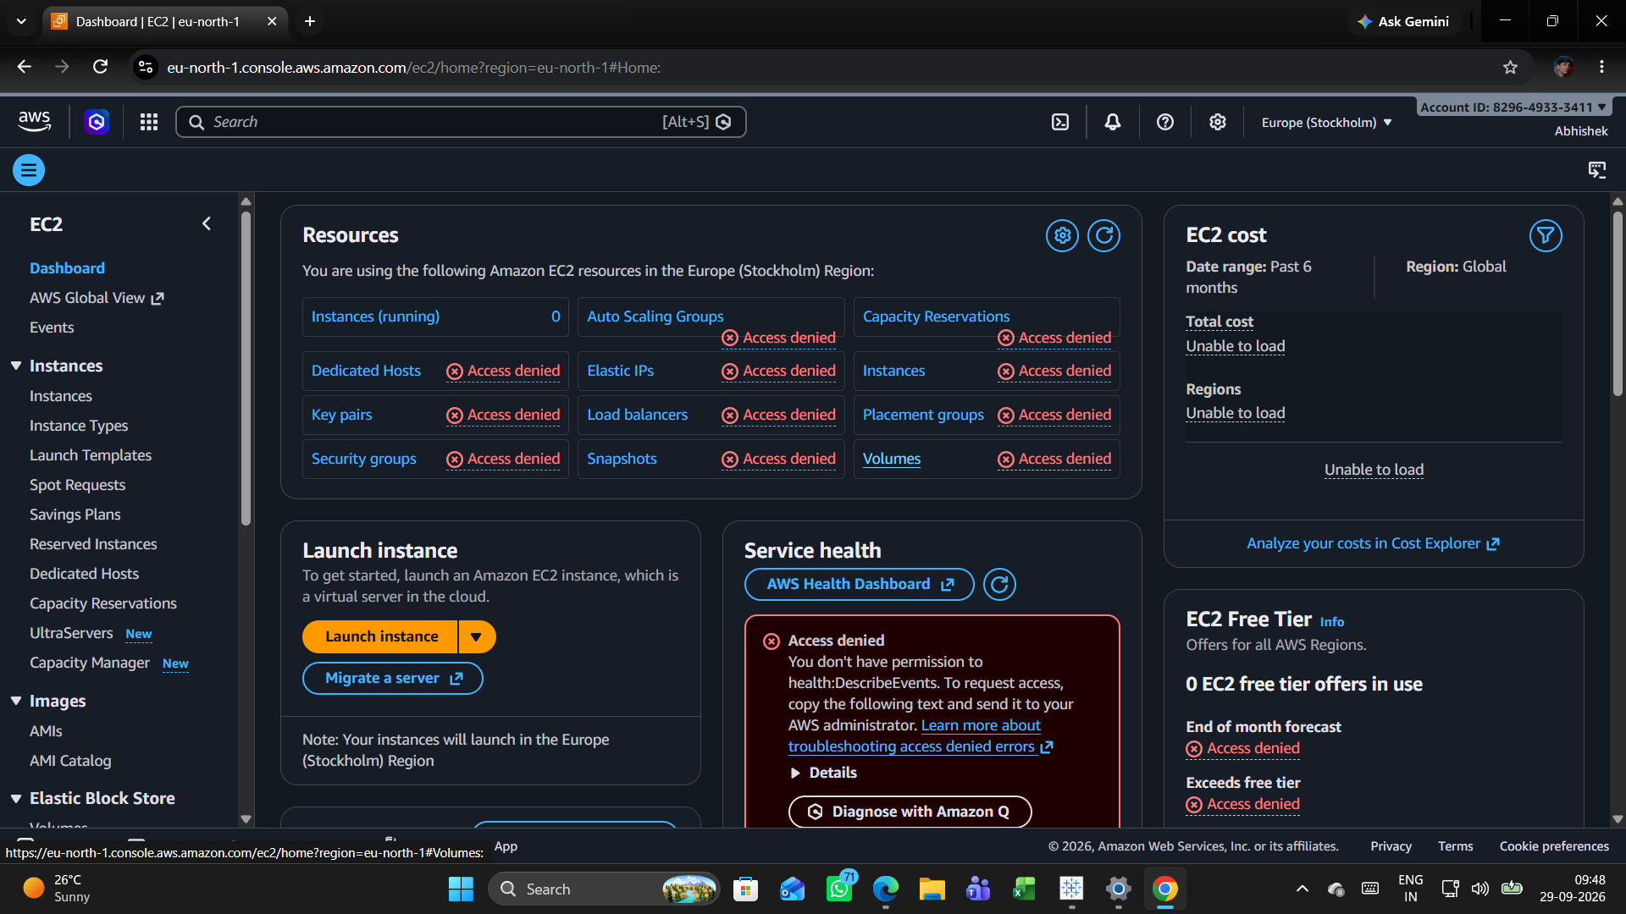
Screenshot 10 – IAM users list
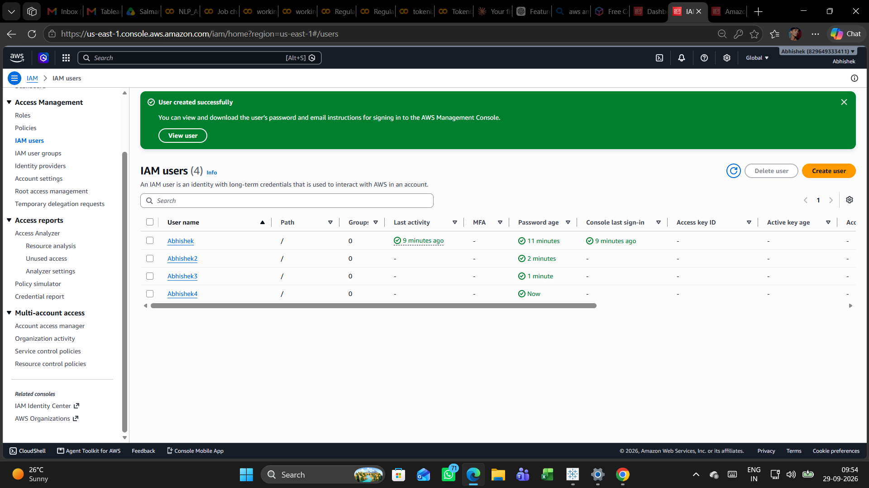
Screenshot 11 – IAM user groups list
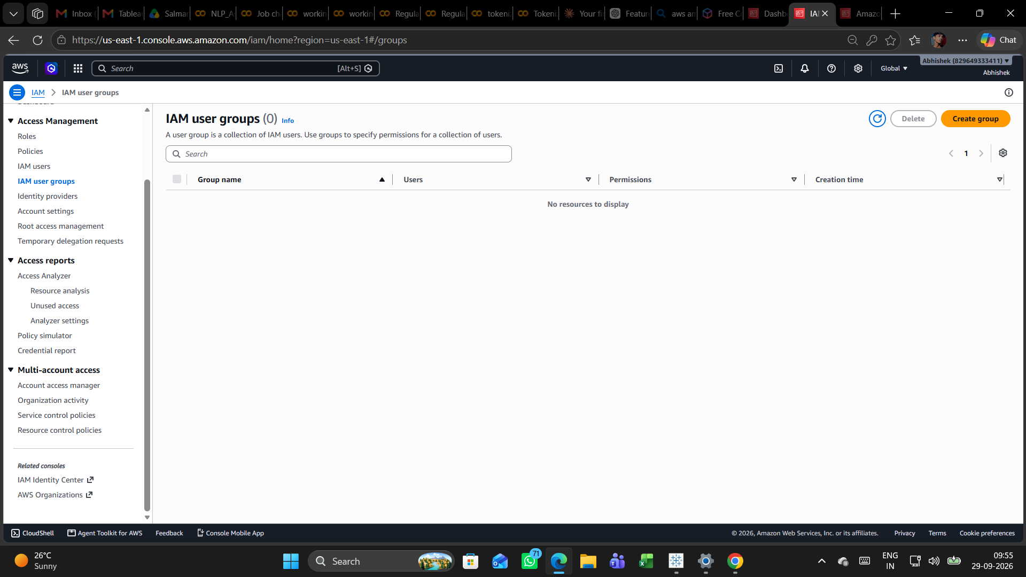
Screenshot 12 – Create user group and select users
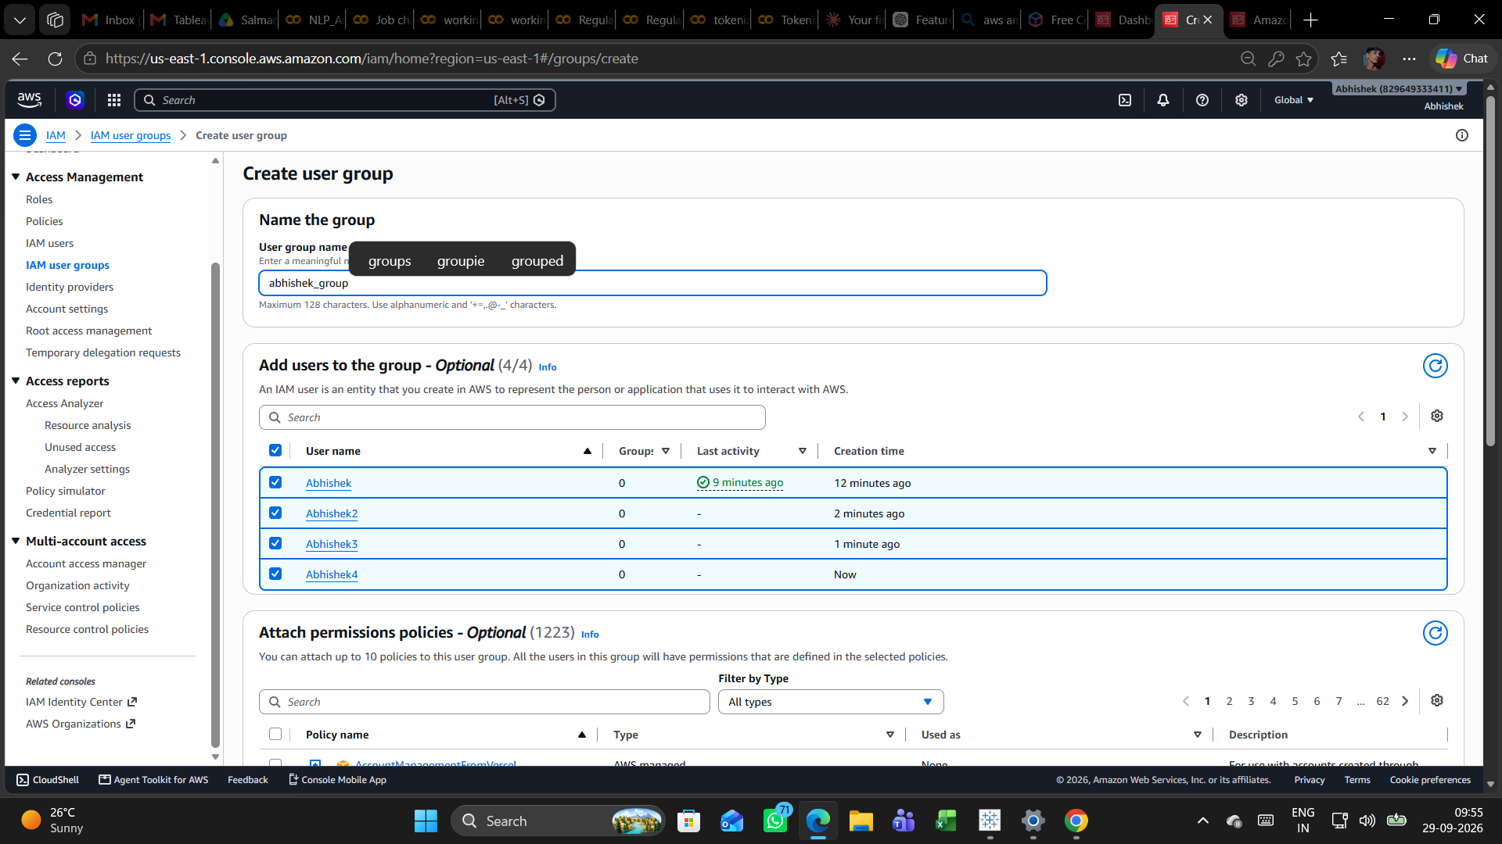
Screenshot 13 – Attach IAMFullAccess to group
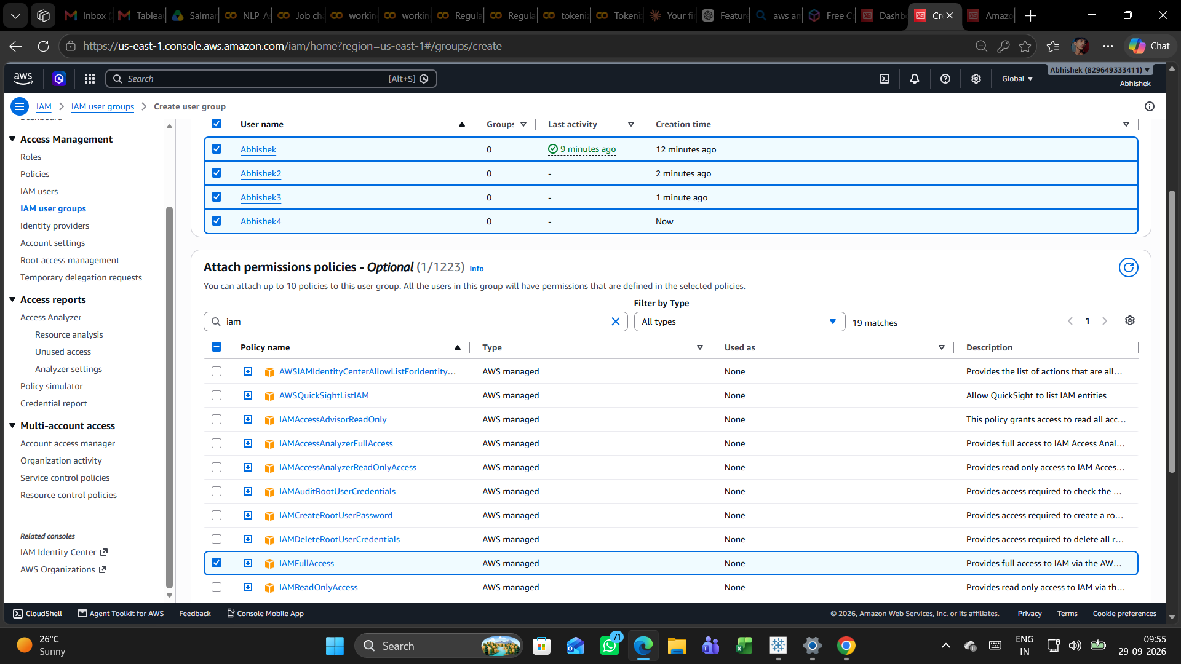
Screenshot 14 – Group creation confirmation
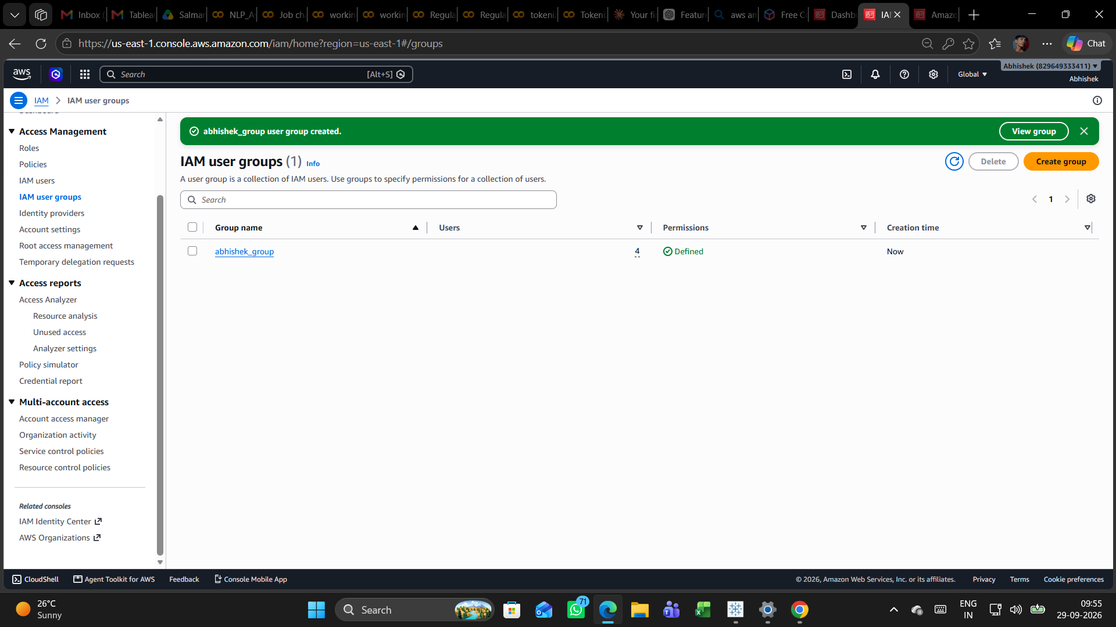
Screenshot 15 – Final group details and four members
